2017 Fall: COMP-SCI 5590/490 - Special Topics

Mobile Programming

Lesson 2

**Lesson Overview**

This lesson helps in understanding some of the basics android by working on intents, layouts, different views thereby getting familiarized with management system. Some elements of Java language are also revisited through In-Class programming.

**Source Code**

<https://umkc.box.com/s/3hvzfbepemv6wk6kvmd7lxno23mvkose>

**In-class Programming – Food ordering App**

Understand the starter code given for ordering coffee and make a mobile application to order a pizza with the following requirements.

1. The main activity should look as below (but should be a pizza version!). Make sure the code does not break when you do so. Add two more options for the toppings. Create the order button and add one more button beside it, which when clicked should display the order summary in a new activity

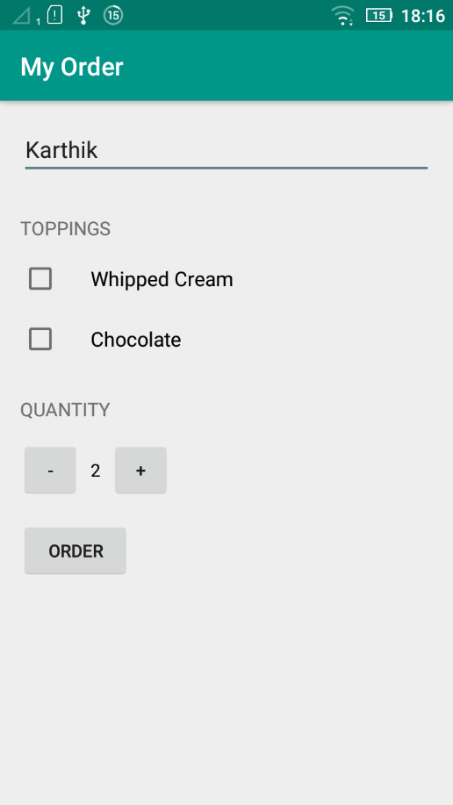

1. After filling the details when the order button is clicked the option to send an email with the summary of the order should be displayed as follows

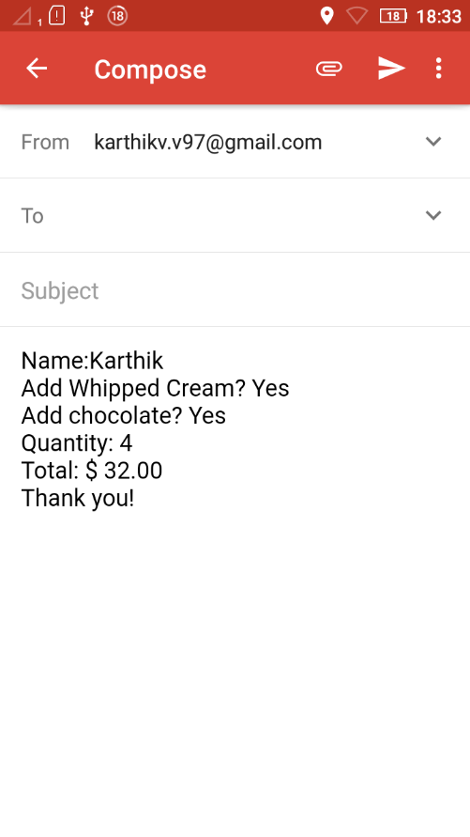

1. Write the xml and java code so that the app works as expected
2. Change the new activity that displays the order so that it is accompanied with a suitable image